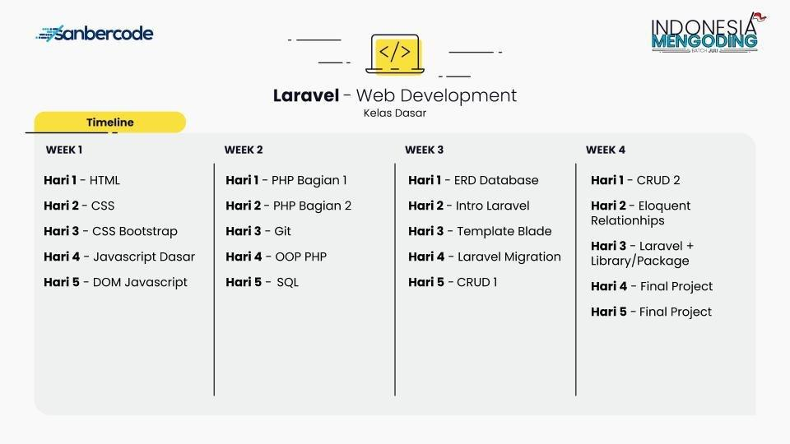

Week 1

- html
- Password: IMLaravelJuli2020
- https://www.youtube.com/playlist?list=PLCZlgfAG0GXC9ojTmU95BRefbJoi4clY-
- https://blog.sanbercode.com/docs/kurikulum-laravel-web-development/pekan-1-materi/hari-1-berkenalan-dengan-html/
- Latihan
https://blog.sanbercode.com/docs/kurikulum-laravel-web-development/pekan-1-tugas-harian/hari-1-berlatih-html/

- css
- Password: IMLaravelJuli2020
- https://blog.sanbercode.com/docs/kurikulum-laravel-web-development/pekan-1-materi/hari-2-menghias-web-dengan-css/
- https://www.youtube.com/playlist?list=PLFIM0718LjIUBrbm6Gdh6k7ZUvPIAZm7p
- https://github.com/hacktiv8/phase-0-activities/blob/master/modules/css3-basics.md
- Latihan
https://blog.sanbercode.com/docs/kurikulum-laravel-web-development/pekan-1-tugas-harian/hari-2-berlatih-css/

- css boostrap
- Password: IMLaravelJuli2020
- https://blog.sanbercode.com/docs/kurikulum-laravel-web-development/pekan-1-materi/hari-3-lebih-rapi-dengan-css-bootstrap/
- https://www.youtube.com/playlist?list=PLce3Eyp7oY9-o3JavSawkXcazJSYx7KAf
- https://www.youtube.com/playlist?list=PL4cUxeGkcC9jE_cGvLLC60C_PeF_24pvv
- https://getbootstrap.com/docs/4.5/getting-started/introduction/
- https://www.youtube.com/playlist?list=PL8YCzrSDCR7hH_UjtVB7joprW0K-2rThh

- Latihan
https://blog.sanbercode.com/docs/kurikulum-laravel-web-development/pekan-1-tugas-harian/hari-3-berlatih-css-bootstrap/

- javascrip dasar
- Password: IMLaravelJuli2020
- https://youtu.be/w-ttlhBxTxE
- https://www.youtube.com/playlist?list=PLCZlgfAG0GXAiH1acKFPx8EtpJAq44gjP
- Latihan
https://blog.sanbercode.com/docs/kurikulum-laravel-web-development/pekan-1-tugas-harian/hari-4-javascript-dasar/

- dom javascrip
- Password: IMLaravelJuli2020
- https://youtu.be/RKsapPaUgww
- https://blog.sanbercode.com/docs/kurikulum-laravel-web-development/pekan-1-materi/hari-5-dom-javascript/
- https://www.youtube.com/playlist?list=PLFIM0718LjIWB3YRoQbQh82ZewAGtE2-3
- Latihan
https://blog.sanbercode.com/docs/kurikulum-laravel-web-development/pekan-1-tugas-harian/hari-5-dom-javascript/

Week 2
- php bagian 1
- Password: IMLaravelJuli2020
- https://blog.sanbercode.com/docs/kurikulum-laravel-web-development/pekan-2-materi/day-1-php-dasar-1-string-dan-array/
- https://www.youtube.com/playlist?list=PLdMopq3Lfhpdfgo91tsv3MfhXXbNLQBV3
- https://www.youtube.com/playlist?list=PLFIM0718LjIUqXfmEIBE3-uzERZPh3vp6
- Latihan
https://blog.sanbercode.com/docs/kurikulum-laravel-web-development/pekan-2-tugas-harian/hari-1-php-bagian-1-string-dan-array/

- php bagian 2
- Password: IMLaravelJuli2020
- https://blog.sanbercode.com/docs/kurikulum-laravel-web-development/pekan-2-materi/hari-2-php-dasar-2-function-looping-control-flow/
- https://www.youtube.com/playlist?list=PLdMopq3Lfhpe4lsVGlTNqHjnupPXvxKrp
- https://www.php.net/manual/en/control-structures.foreach.php
- Latihan
https://blog.sanbercode.com/docs/kurikulum-laravel-web-development/pekan-2-tugas-harian/hari-2-php-bagian-2-function-looping-control-flow/

- git
- Password: IMLaravelJuli2020
- https://blog.sanbercode.com/docs/kurikulum-laravel-web-development/pekan-2-materi/hari-3-command-line-dan-git/
- https://www.youtube.com/watch?v=RwDjePJgnaw
- Latihan
https://blog.sanbercode.com/docs/kurikulum-laravel-web-development/pekan-2-tugas-harian/hari-3-command-line-dan-git/
- oop php
- Password: IMLaravelJuli2020
- https://www.youtube.com/playlist?list=PLCZlgfAG0GXAPy7l4Wgwhz11GbuR-h2M6
- https://www.youtube.com/playlist?list=PLFIM0718LjIWvxxll-6wLXrC_16h_Bl_p
- https://blog.sanbercode.com/docs/kurikulum-laravel-web-development/pekan-2-materi/hari-4-oop-php/
- https://arsiteknologi.com/download-e-book-pemrograman-oop-modern-dengan-php-gratis.html
- https://www.youtube.com/watch?v=7W1MO6atD3g&feature=youtu.be
- Latihan
https://blog.sanbercode.com/docs/kurikulum-laravel-web-development/pekan-2-tugas-harian/hari-4-oop-php/

- sql
- Password: IMLaravelJuli2020
- https://www.youtube.com/playlist?list=PLCZlgfAG0GXBWjBVQYxtx33htv6PqbKMl
- https://www.youtube.com/watch?v=fxe6qev-bno
- https://www.youtube.com/watch?v=hnYlDAfZcMU&feature=youtu.be
- https://www.youtube.com/watch?v=fVb6MiS1Rjg&feature=youtu.be
- Latihan
https://blog.sanbercode.com/docs/kurikulum-laravel-web-development/pekan-2-tugas-harian/hari-5-berlatih-sql/

Week 3
- erd database
- Password: IMLaravelJuli2020
- https://blog.sanbercode.com/docs/kurikulum-laravel-web-development/pekan-3-materi/hari-1-membuat-desain-erd-untuk-database/
- https://app.diagrams.net/
- https://www.youtube.com/watch?v=y_q5x-YOxpM
- Latihan
https://blog.sanbercode.com/docs/kurikulum-laravel-web-development/pekan-3-tugas-harian/hari-1-desain-erd/

- intro laravel
- Password: IMLaravelJuli2020
- https://www.youtube.com/watch?v=tBKOb8Ib5nI
- https://www.youtube.com/playlist?list=PL8YCzrSDCR7it2LAOXVlG3tqtvqBoCn6I
- https://blog.sanbercode.com/docs/kurikulum-laravel-web-development/pekan-3-materi/hari-2-intro-laravel-instalasi-dan-membuat-web-statis/
- Latihan
https://blog.sanbercode.com/docs/kurikulum-laravel-web-development/pekan-3-tugas-harian/hari-2-membuat-web-statis-dengan-laravel/

- template blade
- Password: IMLaravelJuli2020
- https://www.youtube.com/playlist?list=PL8YCzrSDCR7jKAGyOzK_ArZl92RyOXQqM
- Latihan
https://blog.sanbercode.com/docs/kurikulum-laravel-web-development/pekan-3-tugas-harian/hari-3-memasangkan-template-dengan-laravel-blade/
- laravel migration
- Password: IMLaravelJuli2020
- https://www.youtube.com/playlist?list=PL8YCzrSDCR7hlOzhq1qC7hc8QNBwi_nvV
- Latihan
https://blog.sanbercode.com/docs/kurikulum-laravel-web-development/pekan-3-tugas-harian/hari-4-mengatur-database-dengan-migration/

- crud 1
- Password: IMLaravelJuli2020
- https://www.youtube.com/playlist?list=PL8YCzrSDCR7g4IqBTi6zEbJZxyHaYZ9SL
- Latihan
https://blog.sanbercode.com/docs/kurikulum-laravel-web-development/pekan-3-tugas-harian/hari-5-berlatih-crud-di-laravel/

Week 4
- crud 2
- Password: IMLaravelJuli2020

- eloquent relationships
- laravel + library/package
- final project
- final project

